

**FPT ACADEMY INTERNATIONAL**

**FPT – APTECH COMPUTER EDUCATION**

**USER GUIDE FOR CARRVAN WEBSITE**

**I. System Requirement**

|  |  |  |
| --- | --- | --- |
| **No** | **Software** | **Description** |
| **1** | **Operating system** | **Windows 7 or higher** |
| **2** | **Hardware** | **Intel Pentium 4 processor or higher**  **512 Megabytes of RAM or higher** |
| **3** | **Software** | **Visual Studio Code, Dreamweaver** |
| **4** | **Web browser** | **Internet Explorer 11 , Chrome, Firefox, Safari** |

1. **Introduction and website installation**

- This document is created to guide users use the website – CARVAN effectively. It is advisable that users should read this document before starting to use this website in reality.

- To runCARVAN website, users need to do the following steps:

* + - 1. Download the file rar *eProject –* CARVAN *by Group 2 (FPT Aptech HCM)* via this link:
      2. Extract the file rar: *eProject –* CARVAN *by Group 2 (FPT Aptech HCM)*

1. Open the folder *eProject*
2. Open *Index.html* file to start the website. Look at figure 1 for illustration

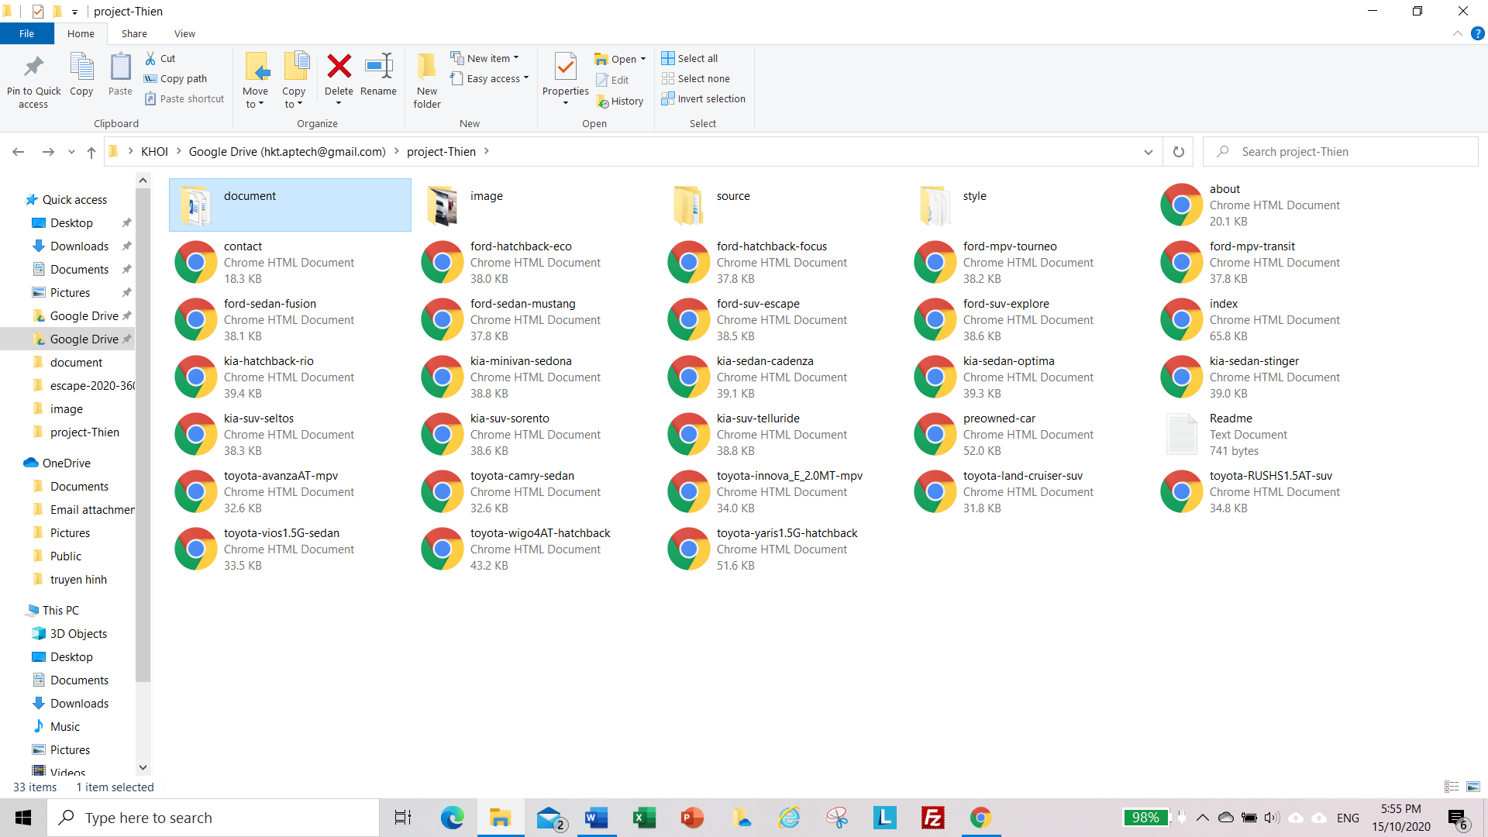

*Figure 1*

1. 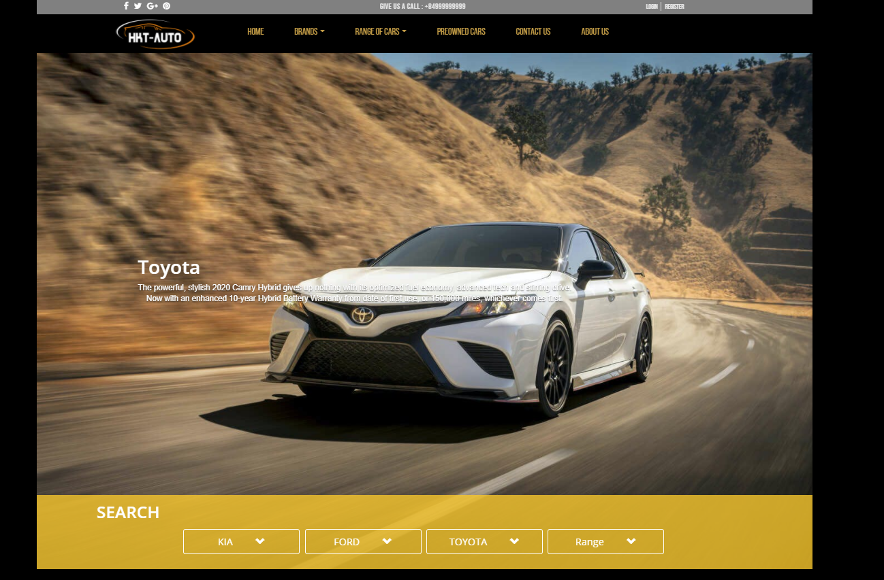If done successfully, users will see the Homepage like figure 2 below

*Figure 2*

1. **Brands**

- This webpage allows users to find the information for the products they’re looking for. To get the details of a particular item, users need to click on image or text, which will automatically open the information page for that item. For example, figure 3 illustrates how to get detailed information for single product.

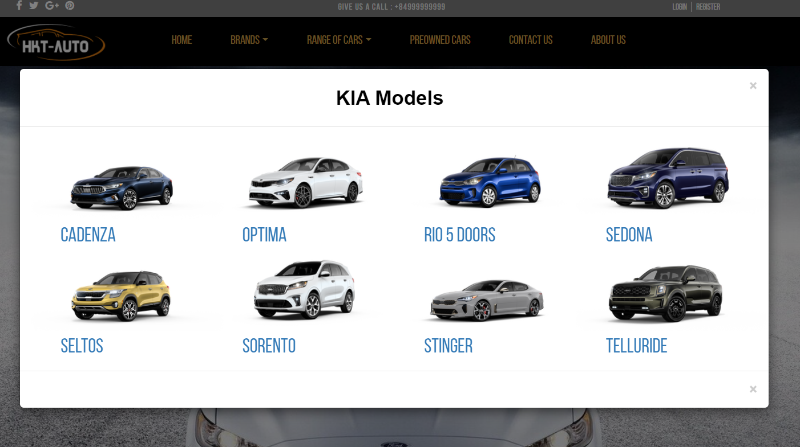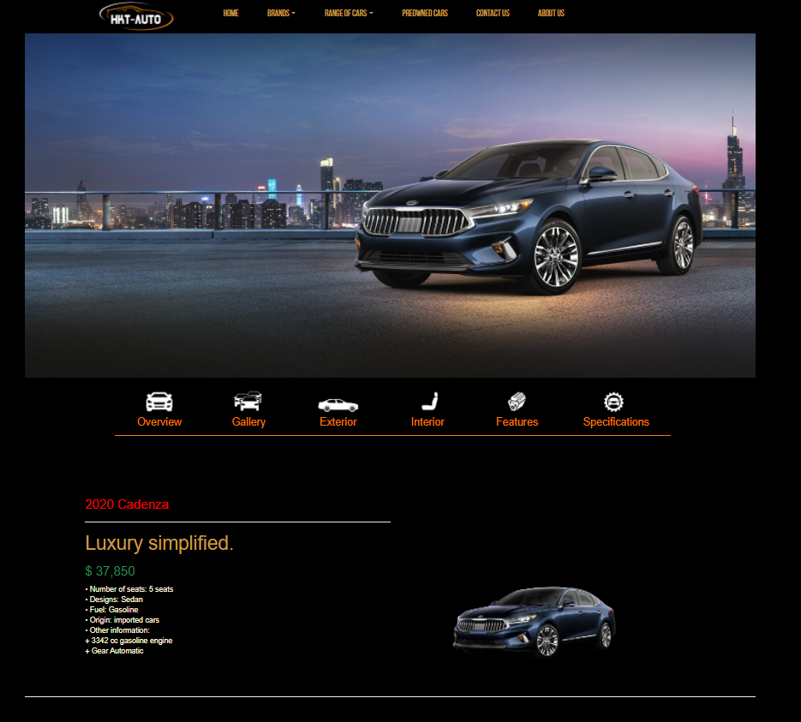

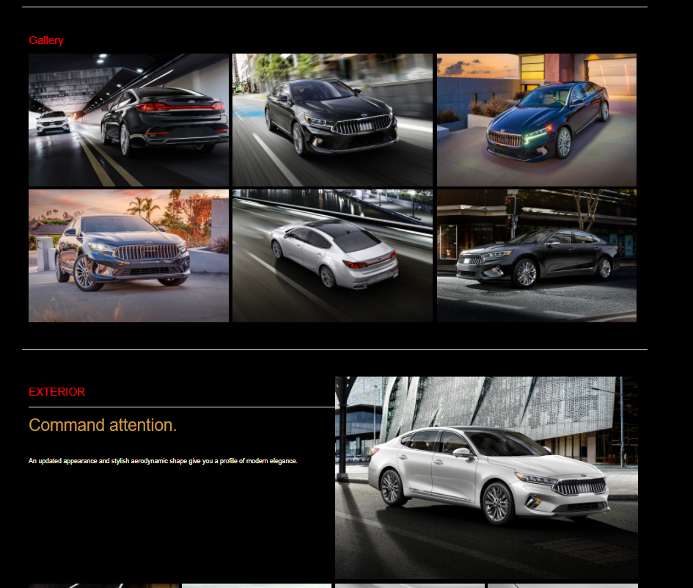

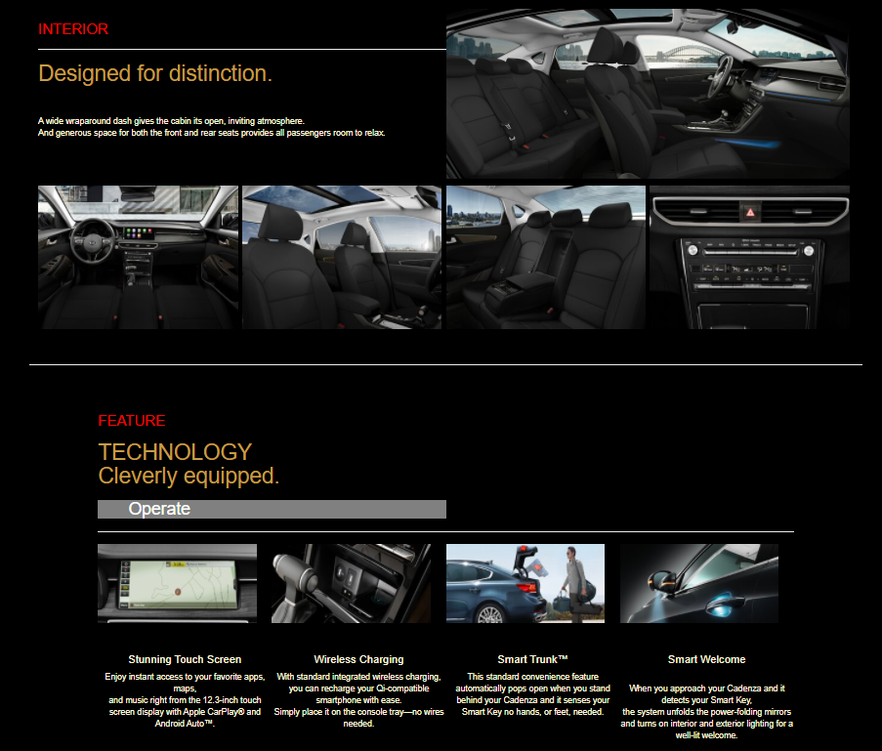

*Figure 3*

- To make it easier for users to find the product as fast as possible, we created to filter option and search bar.

+ As for search bar: To use this function, users need to type the name of a particular product and then press enter. To reset, they need to erase what they typed and press enter.

1. **Range of Cars**

- This part is shown on homepage.

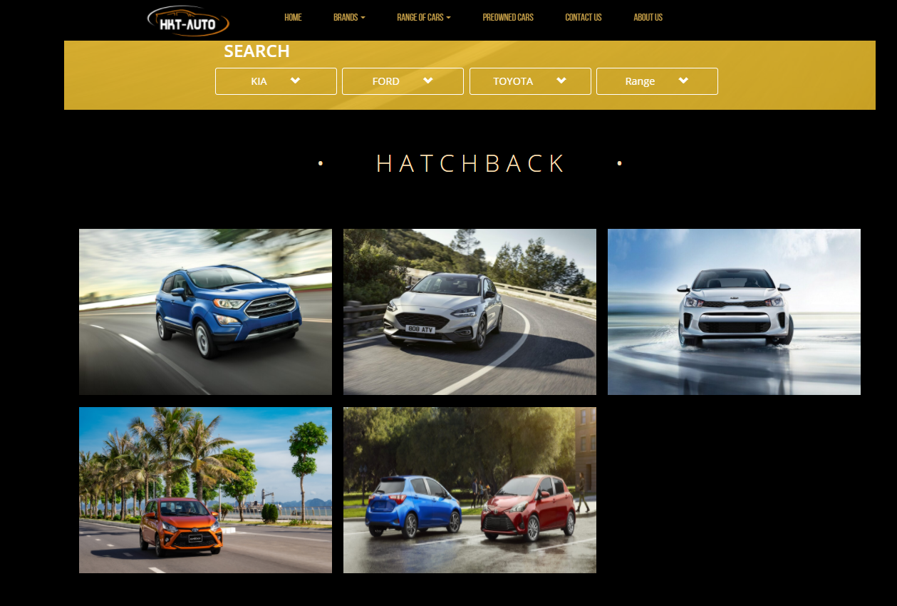

*Figure 4.1*

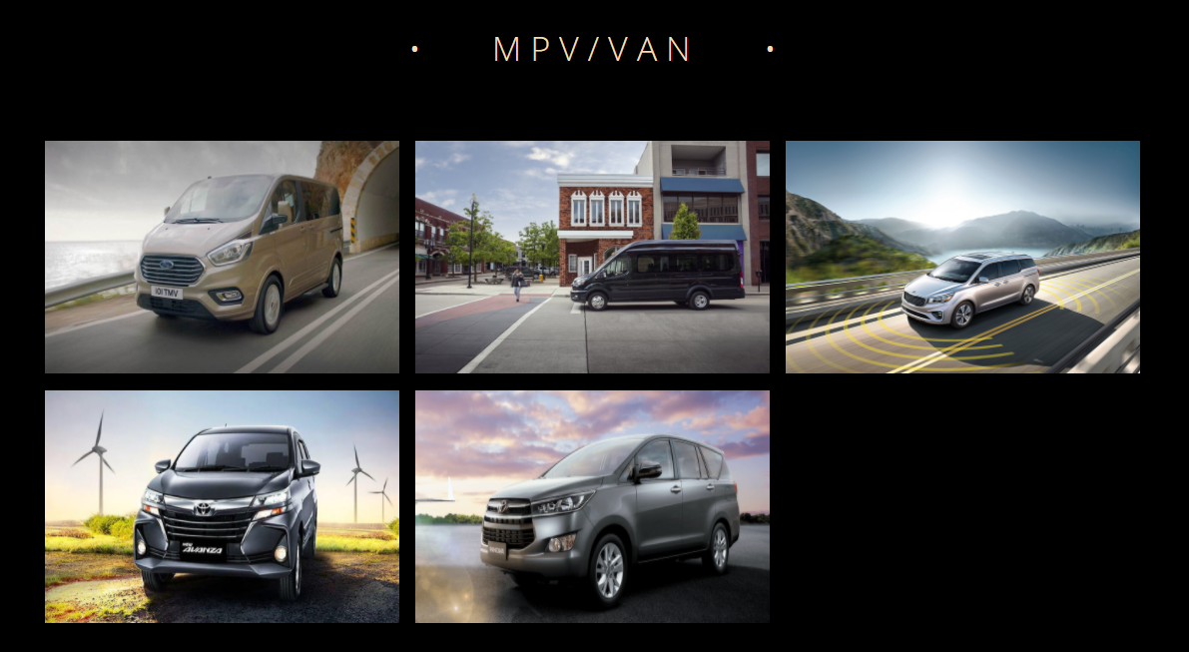

*Figure 4.2*

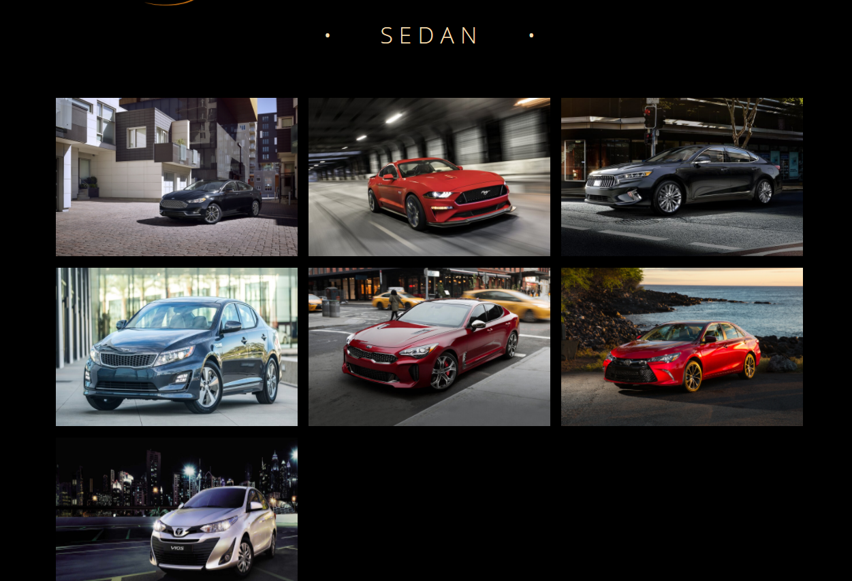

*Figure 4.3*

1. **PreOwned Cars**

This page displays some articles about CPO (Certified Pre-Owned car) (figure 5), when click on 1 specific item, it will show the detail of that item (figure 6).

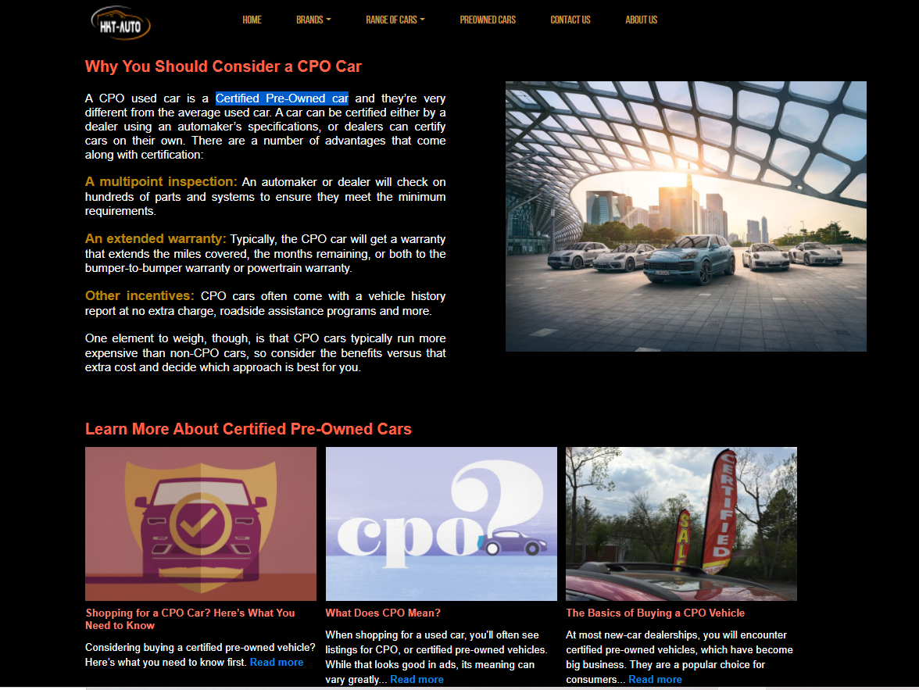

*Figure 5*

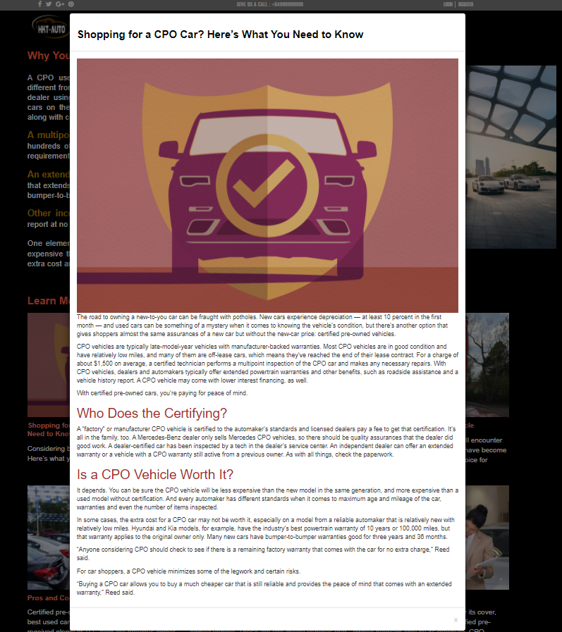

*Figure 6*

*Figure 7*

1. **Contact Us**

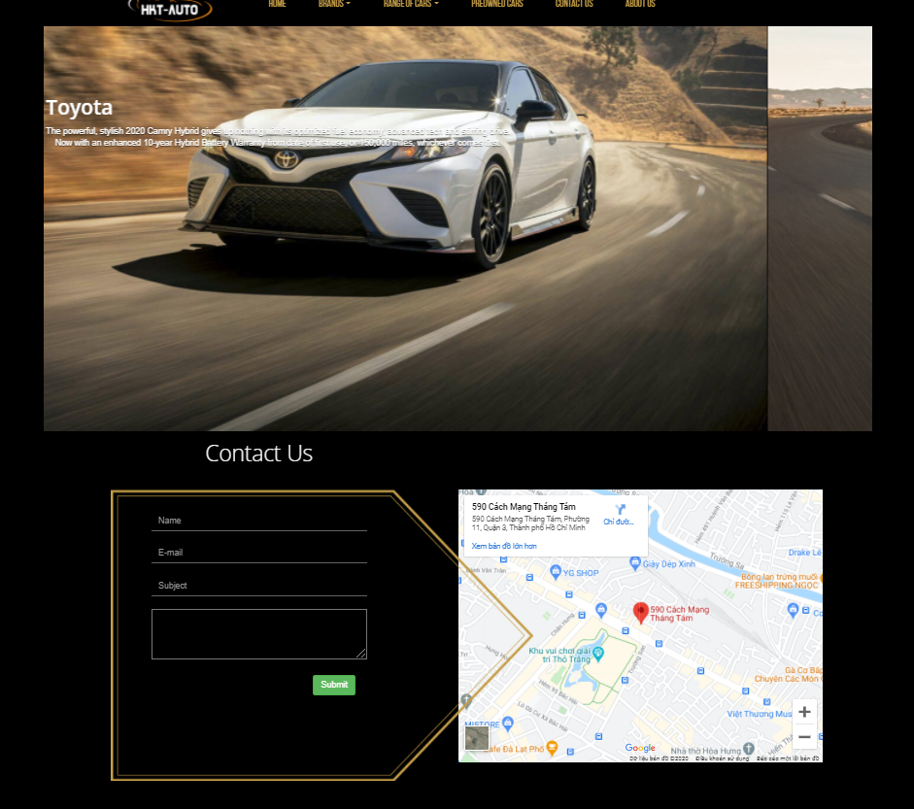- This page displays contact information: location, telephone number, email and a quick contact form for customer.

*Figure 9*

*Figure 8*

1. **About Us**

- This page displays information about the history of CARVAN, our service that we provide and our team member.

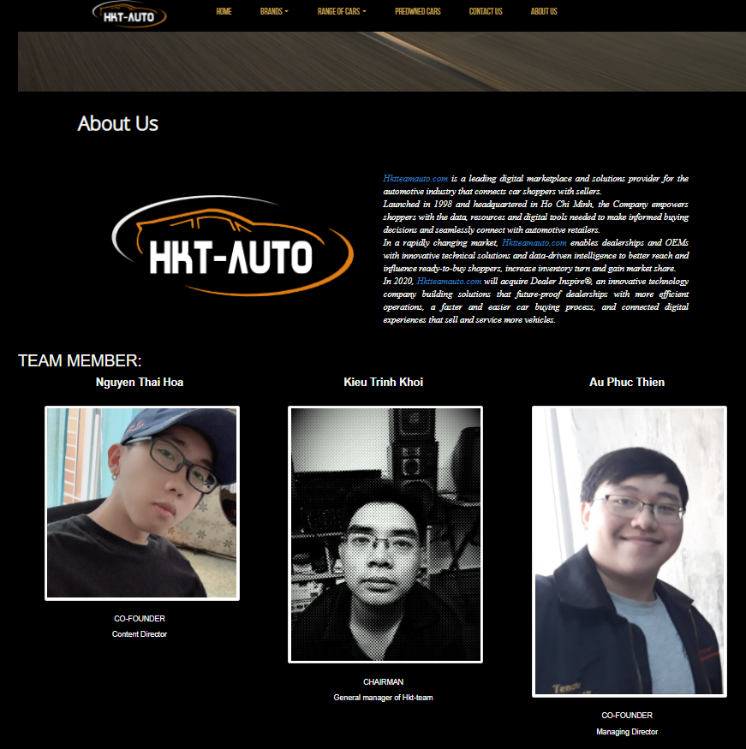

*Figure 9*